Intro to Wireshark Assignment

Step 1:

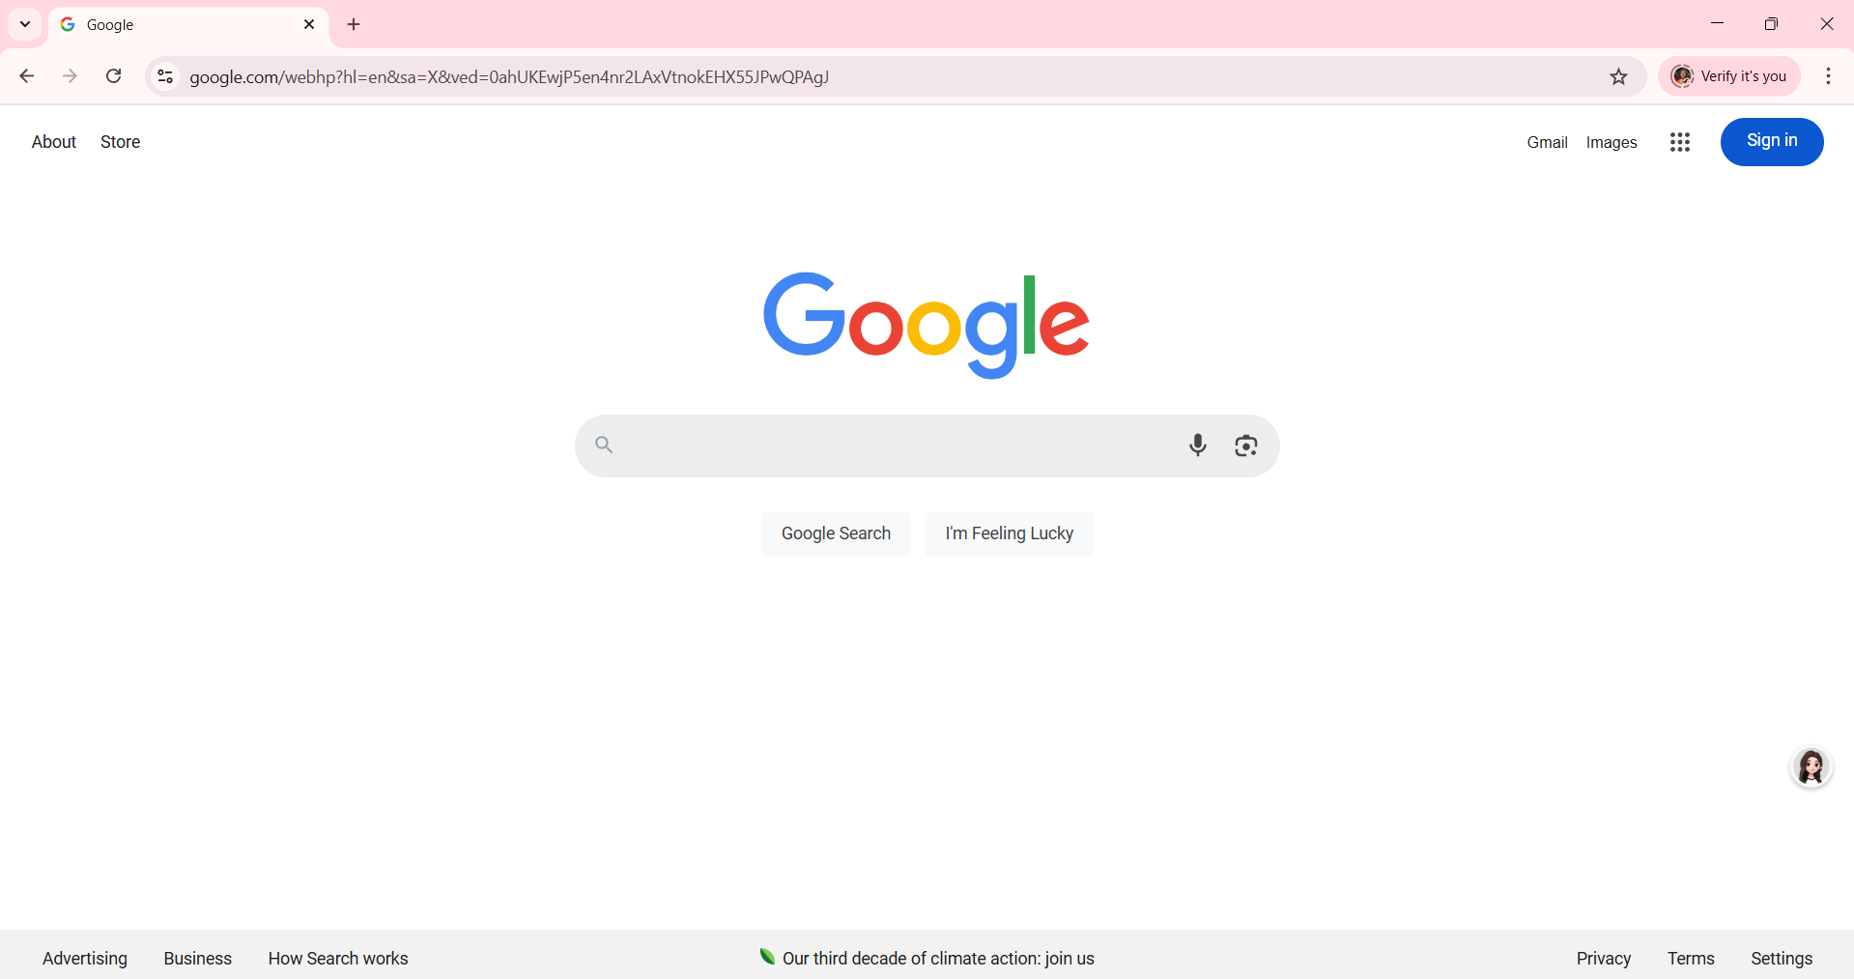

Step 2:

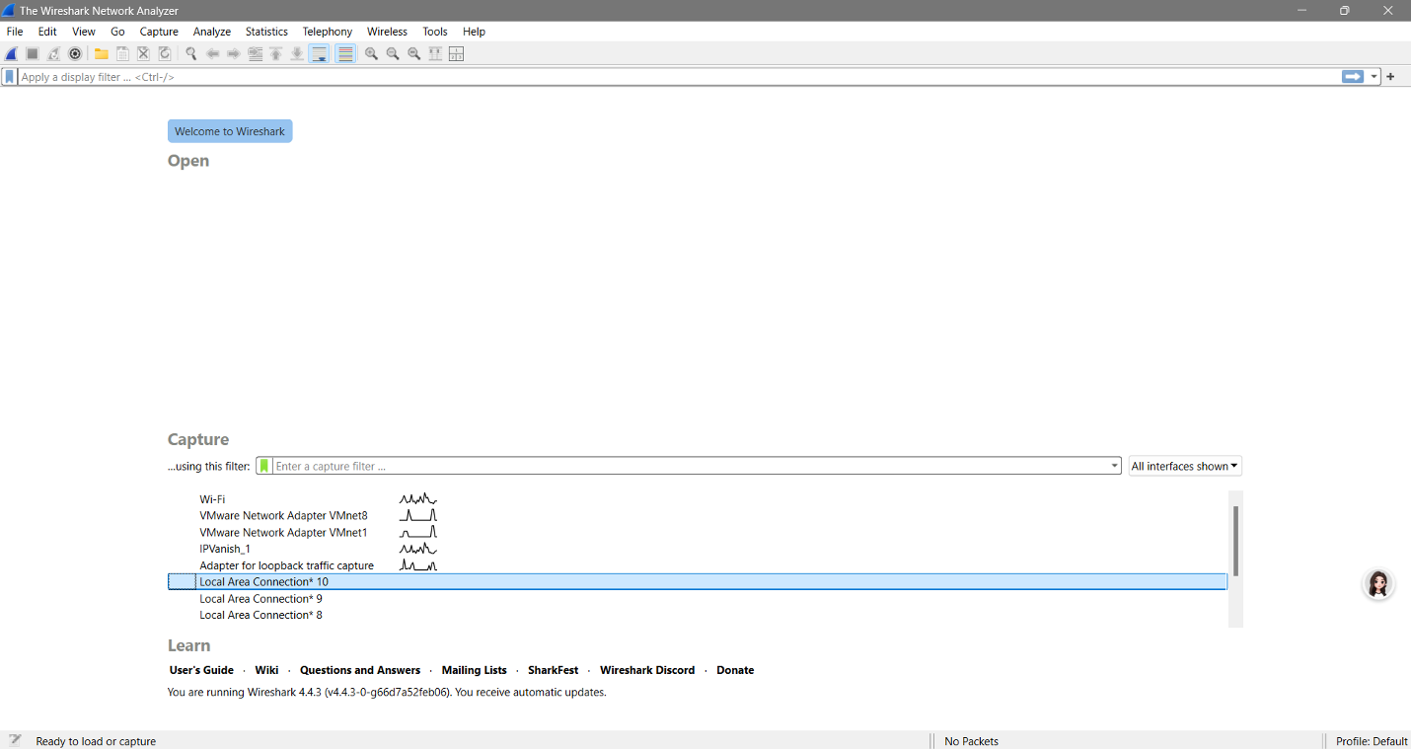

Step 3:

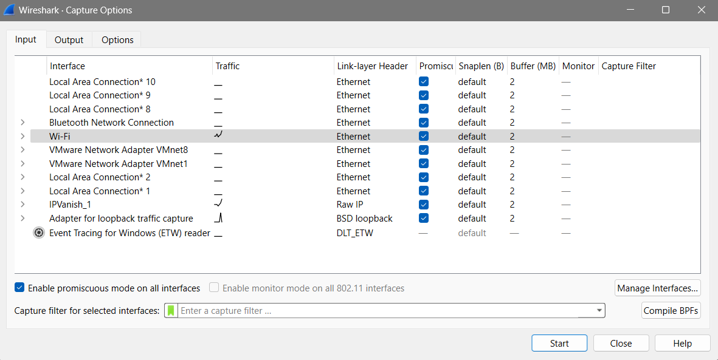

Step 4:

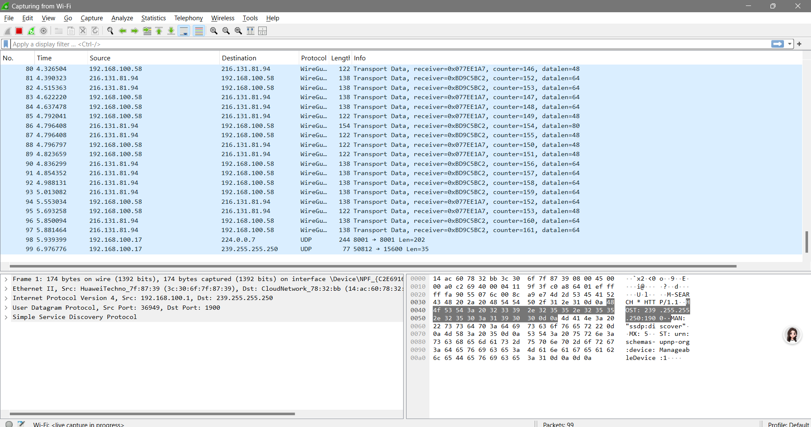

Step 5:

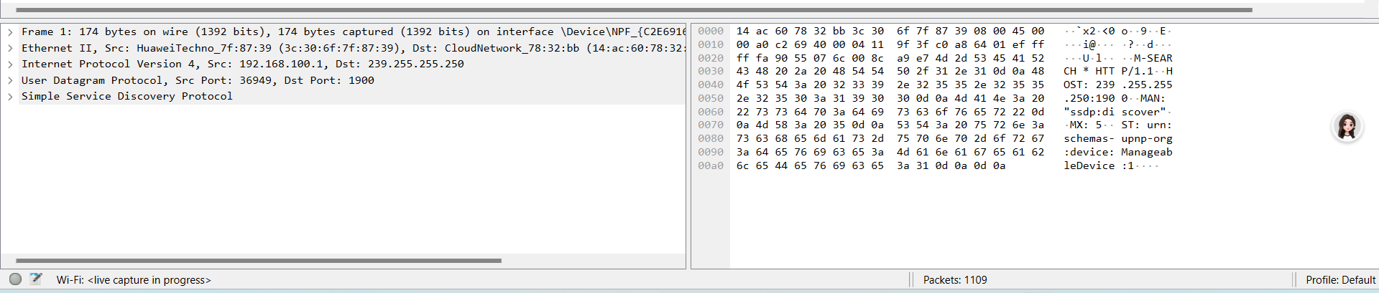

Step 6:

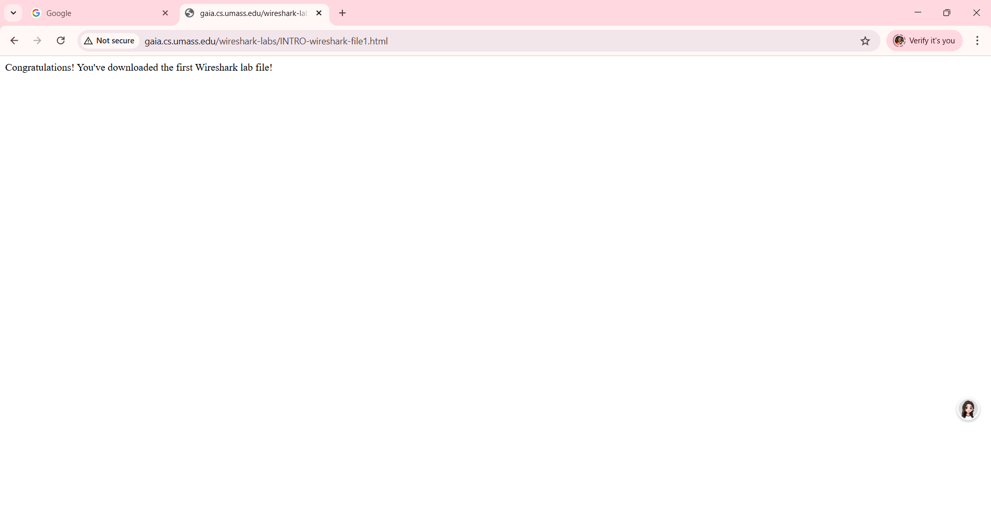

Step 7:

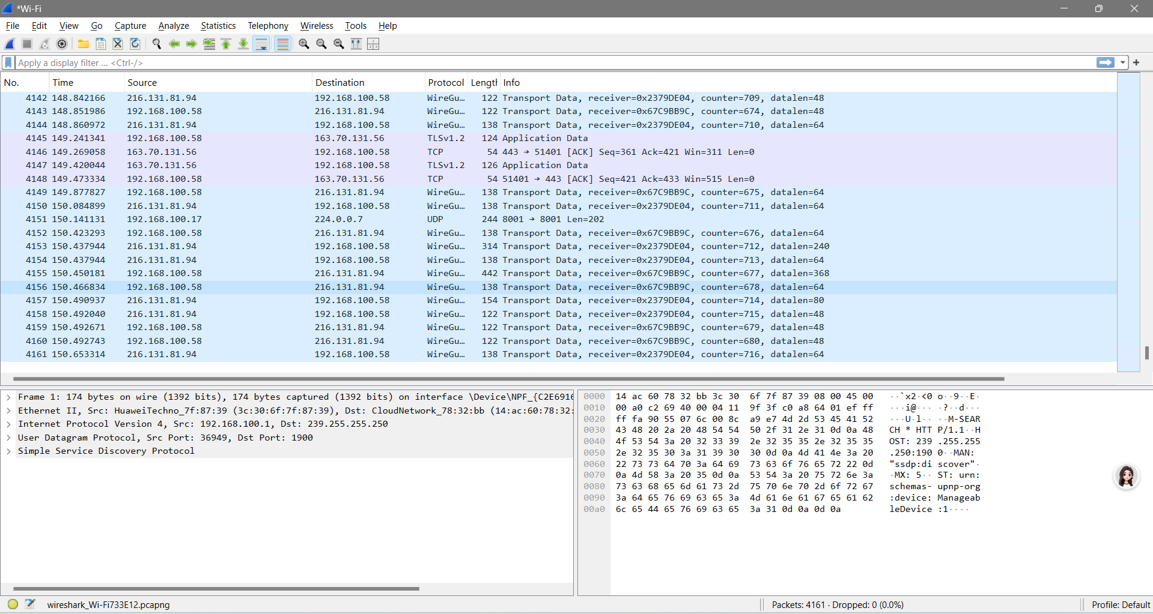

Step 8:

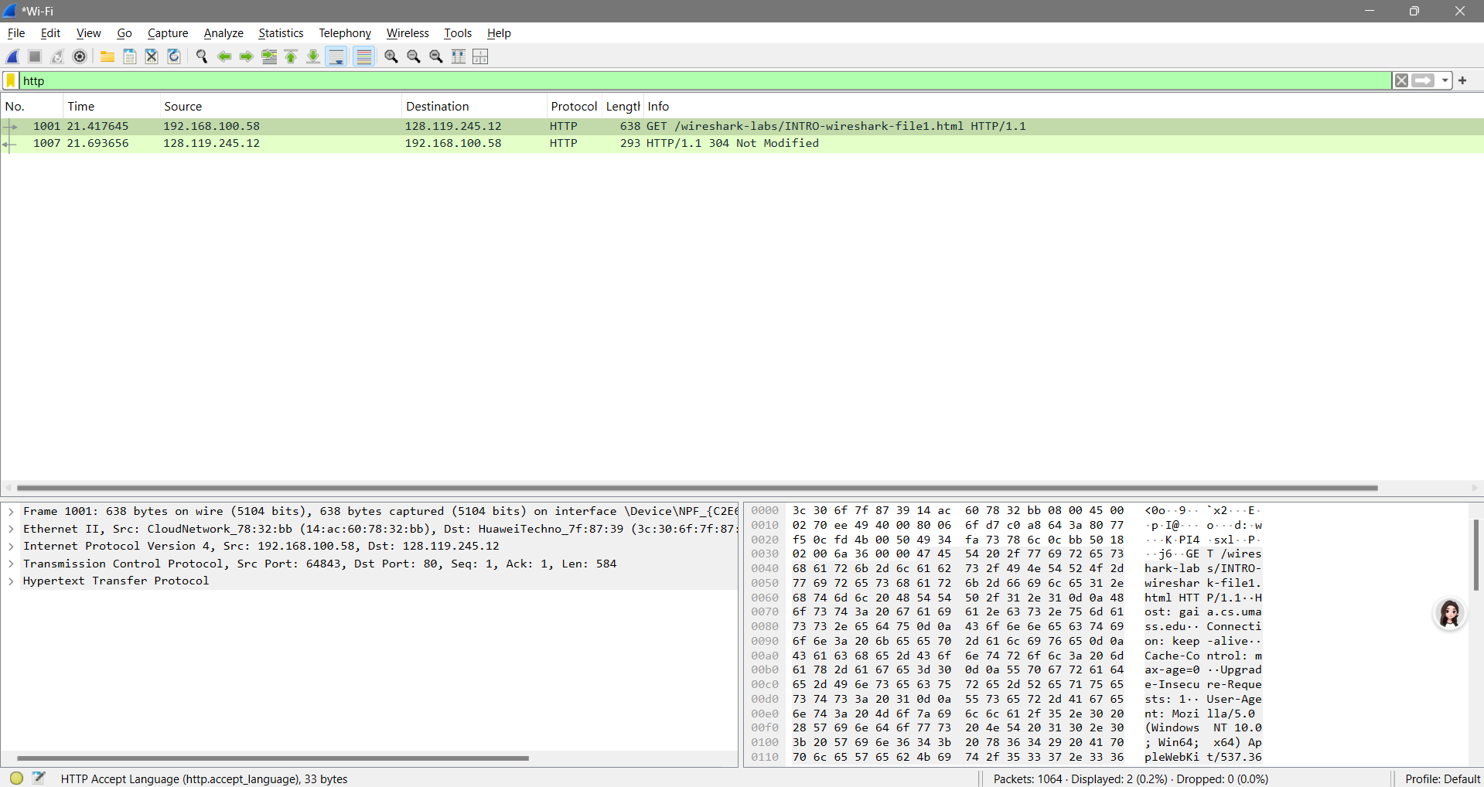

Step 9:

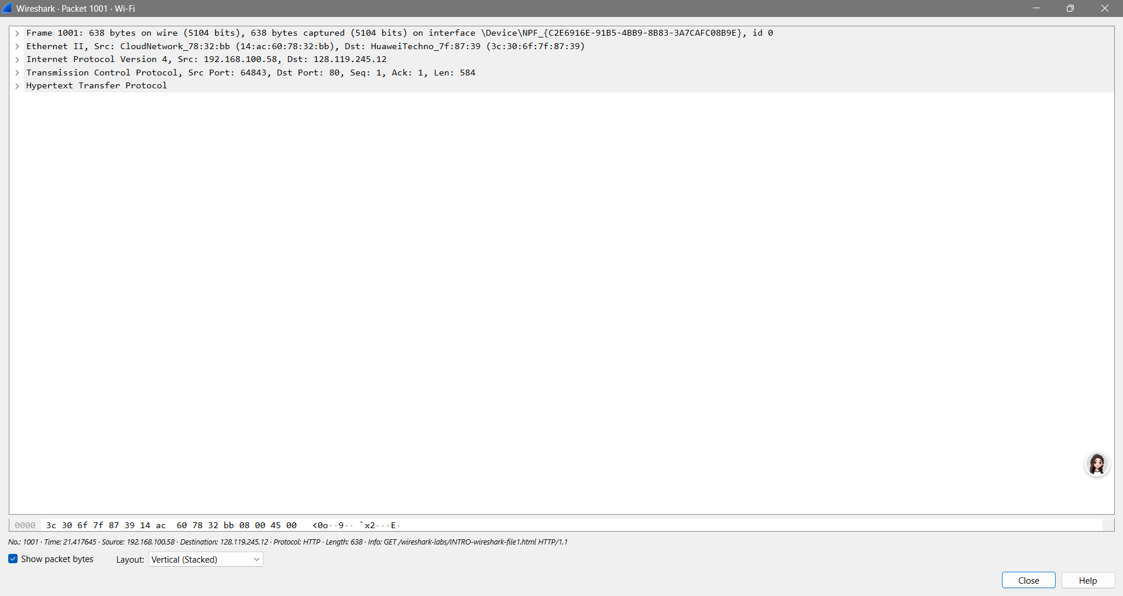

Step 10:

The Wireshark has been closed

Questions and Answers

Answer the following questions, based on your Wireshark experimentation:

1. List up to 10 different protocols that appear in the protocol column in the unfiltered packet-listing window in step 7 above.

* Based on the Wireshark result, the 7 protocols involved in the results are the following:
  + WireGuard
  + TLSv1.2
  + TCP
  + UDP
  + DNS
  + QUIC
  + HTTP
* These are the only protocols present within the Wireshark results

1. How long did it take from when the HTTP GET message was sent until the HTTP OK reply was received? (By default, the value of the Time column in the packet listing window is the amount of time, in seconds, since Wireshark tracing began.

* It took 0.276 seconds from the moment the HTTP GET message was sent until the HTTP OK reply was received.

1. To display the Time field in time-of-day format, select the Wireshark View pull down menu, then select Time Display Format, then select Time-of-day.)

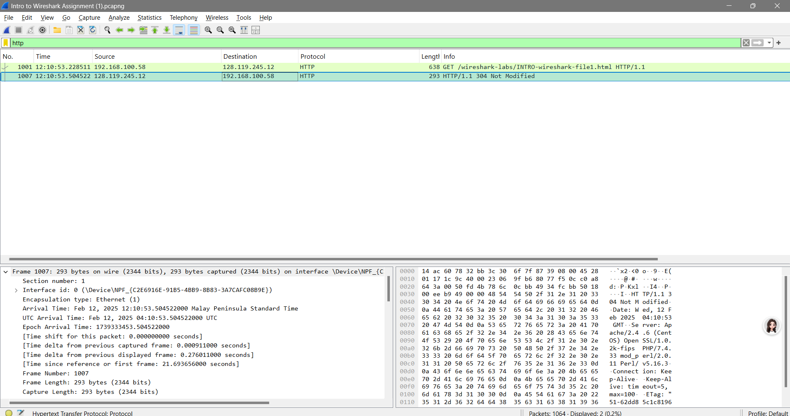

1. What is the Internet address of the gaia.cs.umass.edu (also known as www.net.cs.umass.edu)? What is the Internet address of your computer?

* The internet address of gaia.cs.umass.edu is 128.119.245.12, while my internet address is 192.168.100.58.

1. Print the two HTTP messages displayed in step 9 above. To do so, select Print from the Wireshark File command menu, and select “Selected Packet Only” and “Print as displayed” and then click OK.

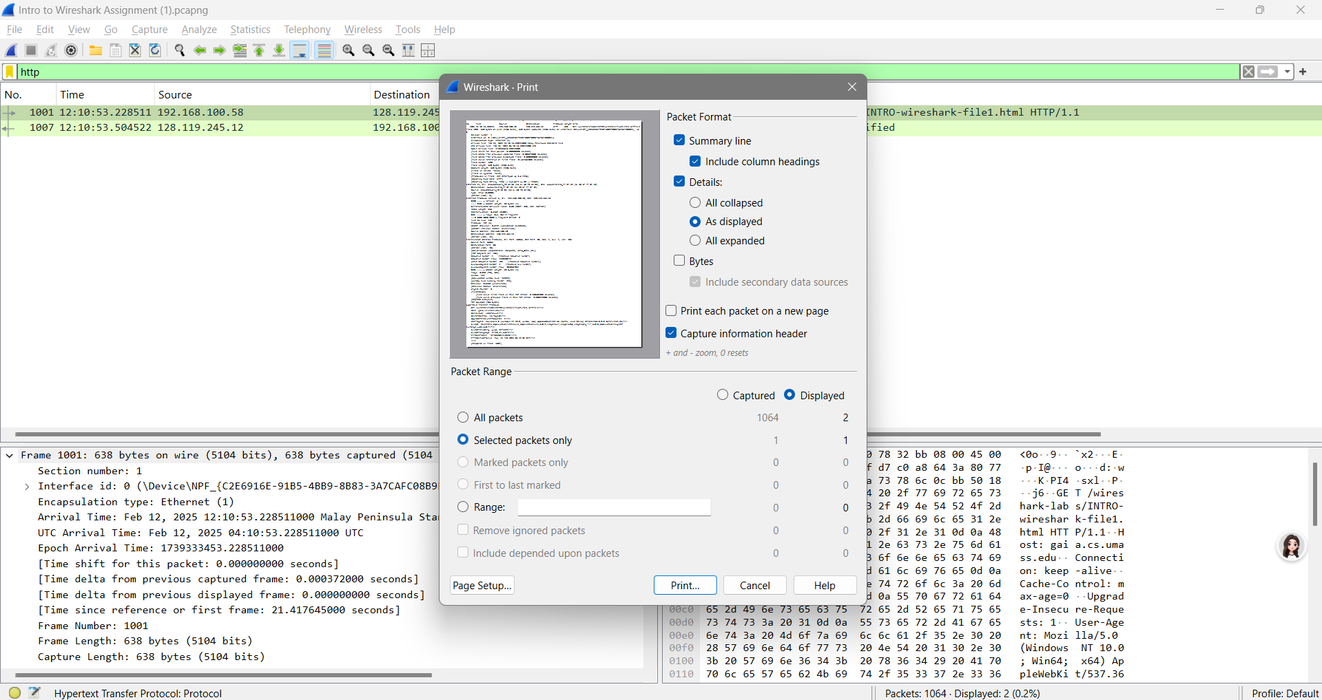

1. Include labeled screenshots from the steps above.
2. Save the packet capture from the lab and submit it as well.

**Congratulations! You’ve now completed the first lab.**